*Syed Muhammad Sarim*

*Lab 8*

*24k-0718*

*Example 1:*

*# include <stdio.h>*

*int main(){*

*int i ,j;*

*for(i=1;i<=5;i++){*

*for(j=1;j<=i;j++){*

*printf("*");*

*}*

*printf("\n");*

*}*

*}*

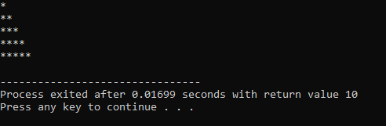

*Example 2:*

*# include <stdio.h>*

*int main(){*

*int i ,j;*

*for(i=1;i<=5;i++){*

*for(j=1;j<=5;j++){*

*printf("%d\t",i*j);*

*}*

*printf("\n");*

*}*

*}*

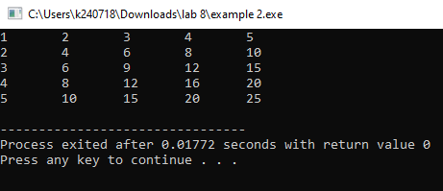

*Example 3:*

*#include <stdio.h>*

*int main() {*

*int rows = 5;*

*for (int i = rows; i >= 1; i--) {*

*for (int j = 1; j <= i; j++) {*

*printf("*");*

*}*

*printf("\n");*

*}*

*return 0;*

*}*

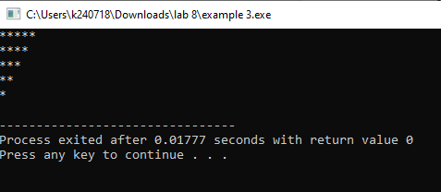

*Example 4:*

*#include <stdio.h>*

*int main() {*

*int mat1[2][2] = {{1, 2}, {3, 4}};*

*int mat2[2][2] = {{5, 6}, {7, 8}};*

*int result[2][2];*

*for (int i = 0; i < 2; i++) {*

*for (int j = 0; j < 2; j++) {*

*result[i][j] = mat1[i][j] + mat2[i][j];*

*}*

*}*

*printf("Sum of two matrices:\n");*

*for (int i = 0; i < 2; i++) {*

*for (int j = 0; j < 2; j++) {*

*printf("%d", result[i][j]);*

*}*

*printf("\n");*

*}*

*return 0;*

*}*

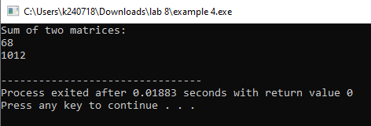

*Example 5:*

*#include<stdio.h>*

*int main() {*

*int arr[2][2][2] = {*

*{{1, 2}, {3, 4}},*

*{{5, 6}, {7, 8}}*

*};*

*for (int i = 0; i < 2; i++) {*

*for (int j = 0; j < 2; j++) {*

*for (int k = 0; k < 2; k++) {*

*printf("%d ", arr[i][j][k]);*

*}*

*printf("\n");*

*}*

*printf("\n");*

*}*

*return 0;*

*}*

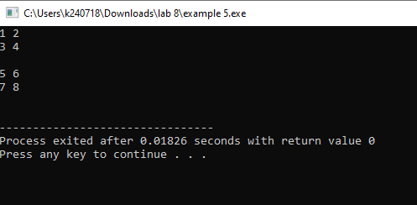

*CLASS TASK 1:*

*# include<stdio.h>*

*int main(){*

*int i,j,num;*

*printf("Enter Rows: ");*

*scanf("%d",&num);*

*for(i=0;i<=num;i++){*

*for(j=1; j<=i; j++){*

*printf(" ");*

*}*

*for(j=0;j<num-i;j++){*

*printf("*");*

*}*

*printf("\n");*

*}*

*}*

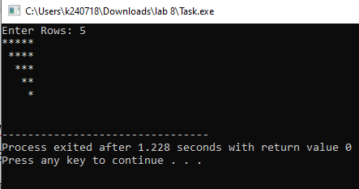

*CLASS TASK 2:*

*# include <stdio.h>*

*int main (){*

*int mat1[2][2] = {{1, 2}, {3, 4}};*

*int i,j,max;*

*max = mat1[0][0];*

*for(i=0;i<2;i++){*

*for(j=0;j< 2;j++){*

*if (mat1[i][j]> max){*

*max = mat1[i][j];*

*}*

*}*

*}*

*printf("The greatest in this array: %d",max);*

*}*

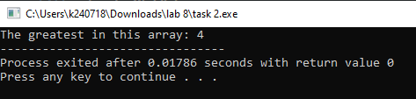

*CLASS TASK 3:*

*# include<stdio.h>*

*int main(){*

*int i ,j,num;*

*printf("Enter Num: ");*

*scanf("%d",&num);*

*for (i=0;i<=num;i++){*

*for(j=1;j<=num-i;j++){*

*printf("%d ",j);*

*}*

*printf("\n");*

*}*

*}*

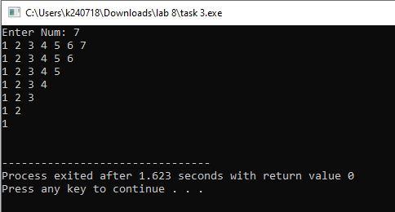

*CLASS TASK 4:*

*#include <stdio.h>*

*#define ROWS 3*

*#define COLS 4*

*int main() {*

*int array[ROWS][COLS] = {*

*{1, 2, 3, 4},*

*{5, 6, 7, 8},*

*{9, 10, 11, 12}*

*};*

*printf("Original Array:\n");*

*for (int i = 0; i < ROWS; i++) {*

*for (int j = 0; j < COLS; j++) {*

*printf("%d ", array[i][j]);*

*}*

*printf("\n");*

*}*

*int temp[ROWS][COLS];*

*for (int i = 0; i < ROWS; i++) {*

*for (int j = 0; j < COLS; j++) {*

*temp[i][j]=array[ROWS-1-i][COLS-1-j];*

*}*

*}*

*printf("Reversed Array:\n");*

*for (int i = 0; i < ROWS; i++) {*

*for (int j = 0; j < COLS; j++) {*

*printf("%d ",temp[i][j]);*

*}*

*printf("\n");*

*}*

*}*

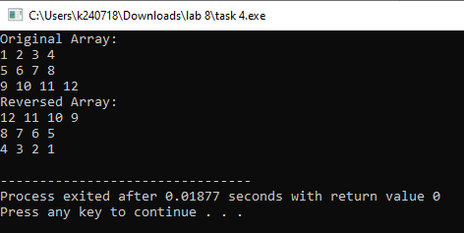

*Section 1 Problem 1:*

*# include<stdio.h>*

*int main(){*

*int i ,j,num;*

*printf("Enter Num: ");*

*scanf("%d",&num);*

*for (i=1;i<=num;i++){*

*for(j=1;j<=i;j++){*

*printf("%d ",j);*

*}*

*printf("\n");*

*}*

*}*

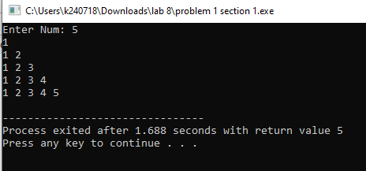

*Section 2 Problem 1:*

*# include <stdio.h>*

*int main (){*

*int r,c;*

*printf("Rows: ");*

*scanf("%d",&r);*

*printf("Cols: ");*

*scanf("%d",&c);*

*int arr[r][c];*

*int i,j;*

*for(i=0;i<r;i++){*

*for(j=0;j<c;j++){*

*printf("enter element of %d row and %d column: ",i,j);*

*scanf("%d",&arr[i][j]);*

*}*

*}*

*printf("Before:\n");*

*for(i=0;i<r;i++){*

*for(j=0;j<c;j++){*

*printf("%d ",arr[i][j]);*

*}*

*printf("\n");*

*}*

*printf("Transpose:\n");*

*for(i=0;i<c;i++){*

*for(j=0;j<r;j++){*

*printf("%d ",arr[j][i]);*

*}*

*printf("\n");*

*}*

*printf("\n");*

*}*

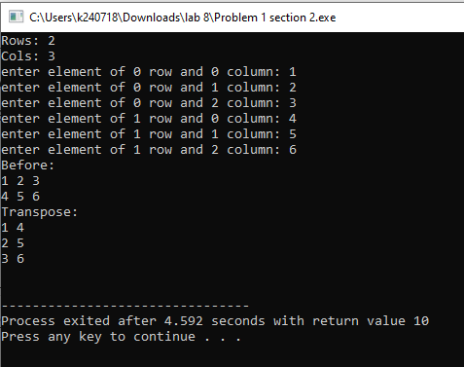

*Section 3 Problem 1:*

*#include <stdio.h>*

*int main() {*

*int array_3d[2][3][3] = {*

*{*

*{1, 2, 3},*

*{4, 5, 6},*

*{7, 8, 9}*

*},*

*{*

*{10,11,12},*

*{13,14,15},*

*{16,17,18}*

*}*

*};*

*int sum[2] = {0};*

*for (int page = 0; page < 2; page++) {*

*for (int row = 0; row < 3; row++) {*

*for (int col = 0; col < 3; col++) {*

*printf("%d ",array_3d[page][row][col]);*

*sum[page] += array_3d[page][row][col];*

*}*

*printf("\n");*

*}*

*printf("\n");*

*printf("")*

*}*

*for (int page = 0; page < 2; page++) {*

*printf("Sum of elements on page %d: %d\n", page + 1, sum[page]);*

*}*

*return 0;*

*}*

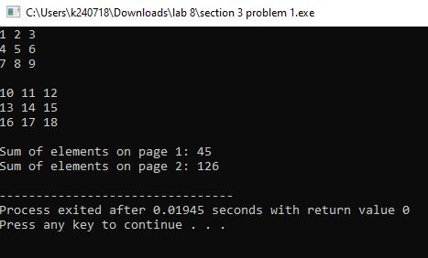

*More Problem’s:*

*Q1.*

*#include <stdio.h>*

*int main(){*

*int n,i,j;*

*printf("Enter a number: ");*

*scanf("%d",&n);*

*int prime=1;*

*printf("The sequence is: ");*

*for (i=2;i<=n;i++){*

*prime = 1;*

*j=2;*

*while(j<i){*

*if (i%j==0)*

*prime=0;*

*j++;*

*}*

*if (prime){*

*printf("%d ",i);*

*}*

*}*

*return 0;*

*}*

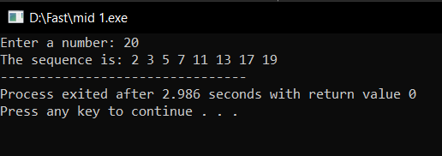

*Q2.*

*#include <stdio.h>*

*int main() {*

*int num, i, j;*

*printf("Enter an odd number: ");*

*scanf("%d", &num);*

*if (num % 2 == 0) {*

*printf("Please enter an odd number.\n");*

*return 1;*

*}*

*for (i = num; i > 0; i = i - 2) {*

*for (j = i; j > 0; j =j- 2) {*

*printf("%d ", j);*

*}*

*printf("\n");*

*}*

*return 0;*

*}*

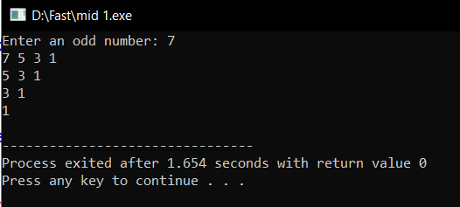

*Q3.*

*#include <stdio.h>*

*int main() {*

*int matrix[3][3];*

*int i, j, k;*

*int saddlePointFound = 0;*

*printf("Enter the elements of a 3x3 matrix:\n");*

*for (i = 0; i < 3; i++) {*

*for (j = 0; j < 3; j++) {*

*printf("Enter element in row %d and col %d: ",i+1,j+1);*

*scanf("%d", &matrix[i][j]);*

*}*

*}*

*for (i = 0; i < 3; i++) {*

*int rowMin = matrix[i][0];*

*int colIndex = 0;*

*for (j = 1; j < 3; j++) {*

*if (matrix[i][j] < rowMin) {*

*rowMin = matrix[i][j];*

*colIndex = j;*

*}*

*}*

*int isSaddlePoint = 1;*

*for (k = 0; k < 3; k++) {*

*if (matrix[k][colIndex] > rowMin) {*

*isSaddlePoint = 0;*

*break;*

*}*

*}*

*if (isSaddlePoint) {*

*printf("Saddle point found at (%d, %d): %d\n", i+1, colIndex+1, rowMin);*

*saddlePointFound = 1;*

*}*

*}*

*if (!saddlePointFound) {*

*printf("No saddle point found.\n");*

*}*

*return 0;*

*}*

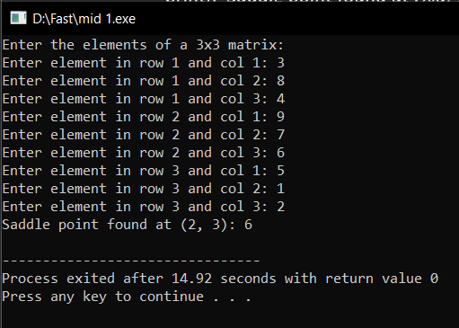

*Q4.*

*#include <stdio.h>*

*int main() {*

*int mat1[3][3] = {{1, 2, 3}, {4, 5, 6}, {7, 8, 9}};*

*int mat2[3][3] = {{10, 11, 12}, {13, 14, 15}, {16, 17, 18}};*

*int result[3][3], i, j, k;*

*for (i = 0; i < 3; i++) {*

*for (j = 0; j < 3; j++) {*

*result[i][j] = 0;*

*for (k = 0; k < 3; k++) {*

*result[i][j] += mat1[i][k] * mat2[k][j];*

*}*

*}*

*}*

*printf("Matix 1:\n");*

*for (i = 0; i < 3; i++) {*

*for (j = 0; j < 3; j++) {*

*printf("%d ",mat1[i][j]);*

*}*

*printf("\n");*

*}*

*printf("Matix 2:\n");*

*for (i = 0; i < 3; i++) {*

*for (j = 0; j < 3; j++) {*

*printf("%d ",mat2[i][j]);*

*}*

*printf("\n");*

*}*

*printf("matrix after multiplication:\n");*

*for (i = 0; i < 3; i++) {*

*for (j = 0; j < 3; j++) {*

*printf("%d ", result[i][j]);*

*}*

*printf("\n");*

*}*

*return 0;*

*}*

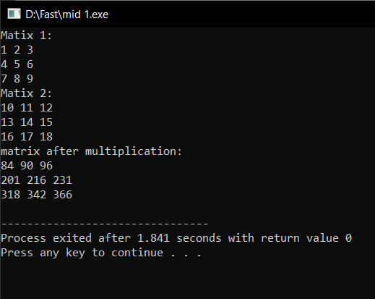

*Q5.*

*#include <stdio.h>*

*int main() {*

*int size, i, j, space;*

*printf("Enter the number of rows: ");*

*scanf("%d", &size);*

*for (i = 1; i <= size; i++) {*

*for (space = 1; space <= size - i; space++) {*

*printf(" ");*

*}*

*for (j = 1; j <= i; j++) {*

*printf("* ");*

*}*

*printf("\n");*

*}*

*for (i = size - 1; i >= 1; i--) {*

*for (space = 1; space <= size - i; space++) {*

*printf(" ");*

*}*

*for (j = 1; j <= i; j++) {*

*printf("* ");*

*}*

*printf("\n");*

*}*

